**EX. NO: 4 DATE: 06/10/2020**

**Creating A Virtual Machine**

**Screenshots:**

**Step 1:**

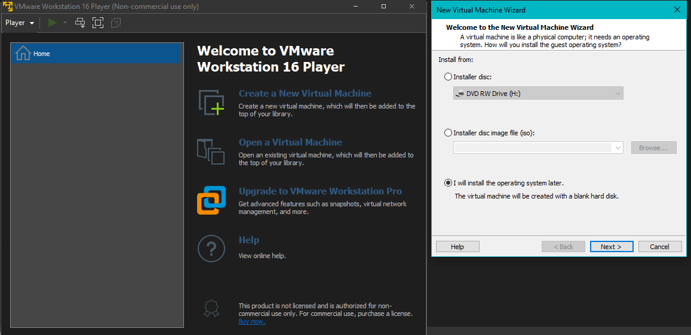

**Step 2:**

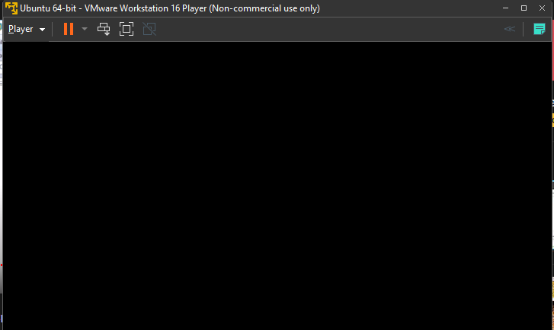

**Step 3:**

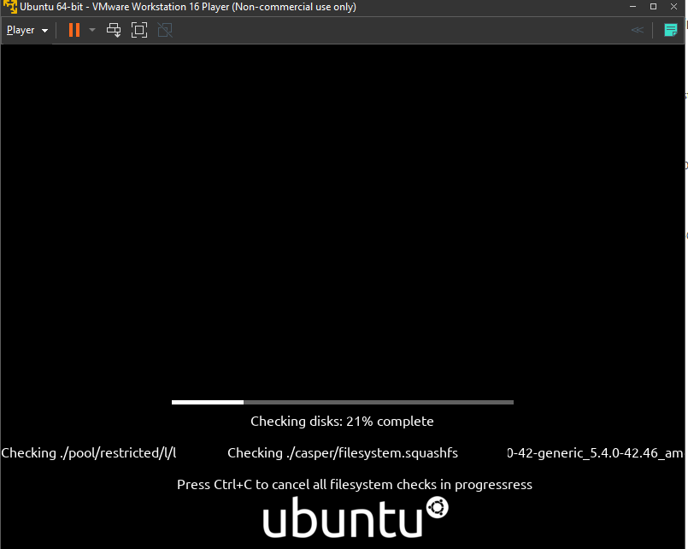

**Step 4:**

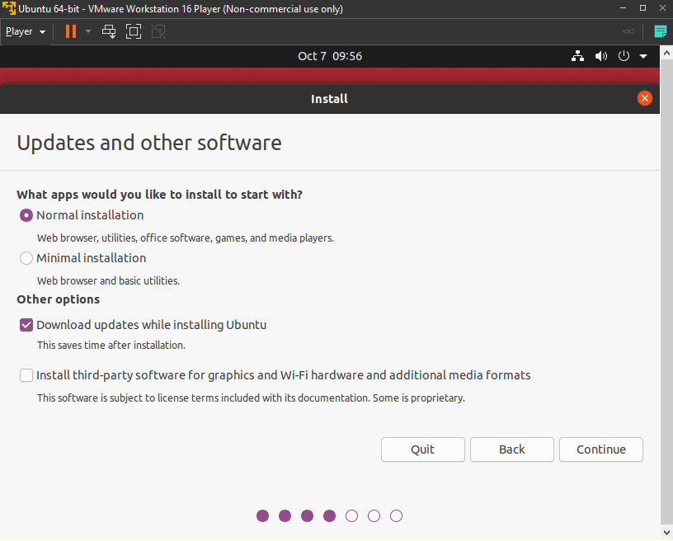

**Step 5:**

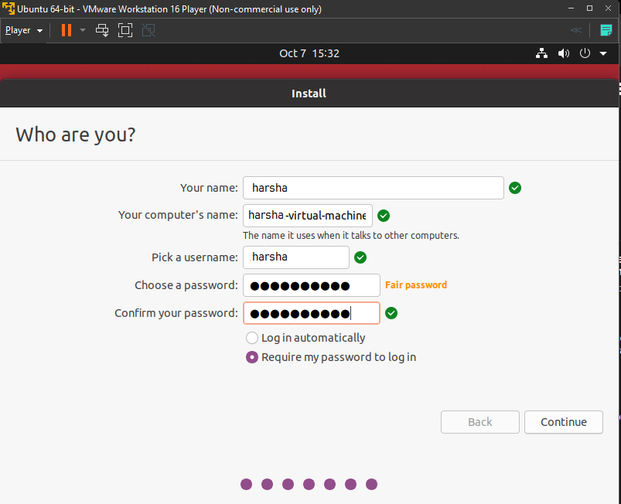

**Step 6:**

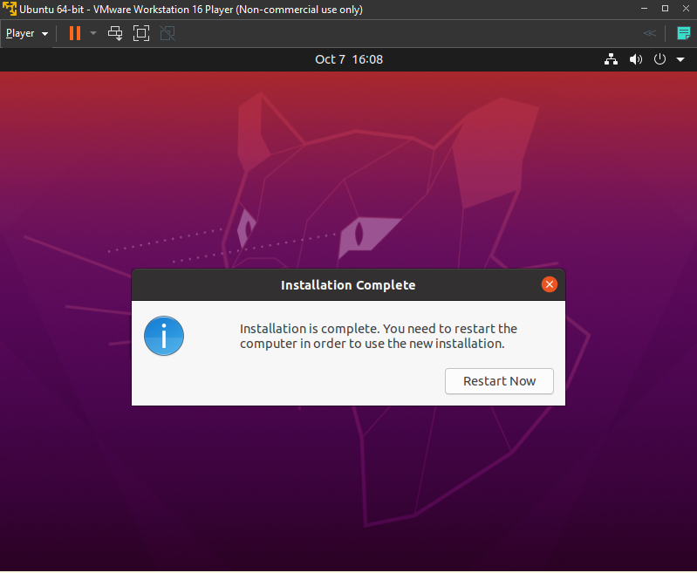

**Step 7:**

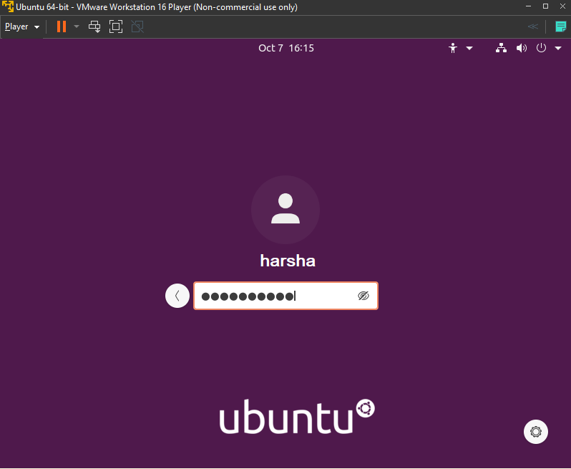

**Step 8:**

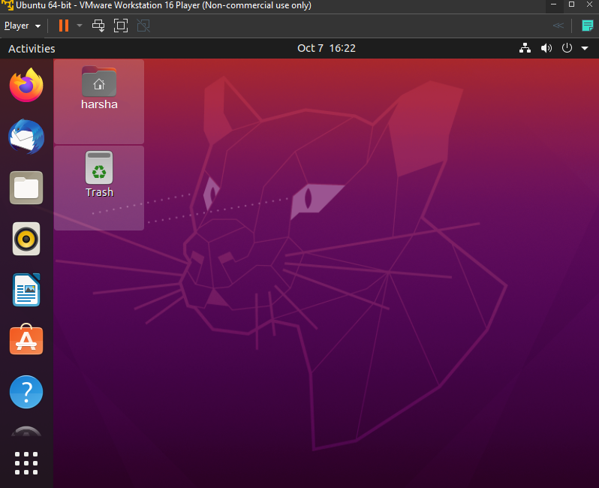

**Step 9:**

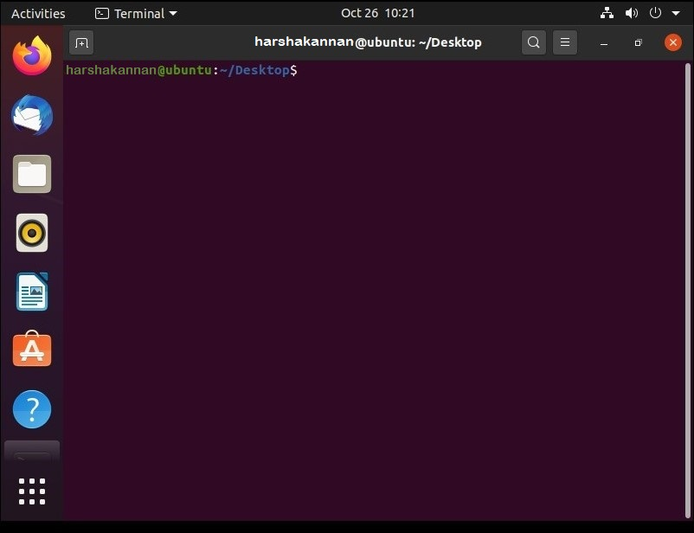

**Playing The Virtual Machine Afterwards:**

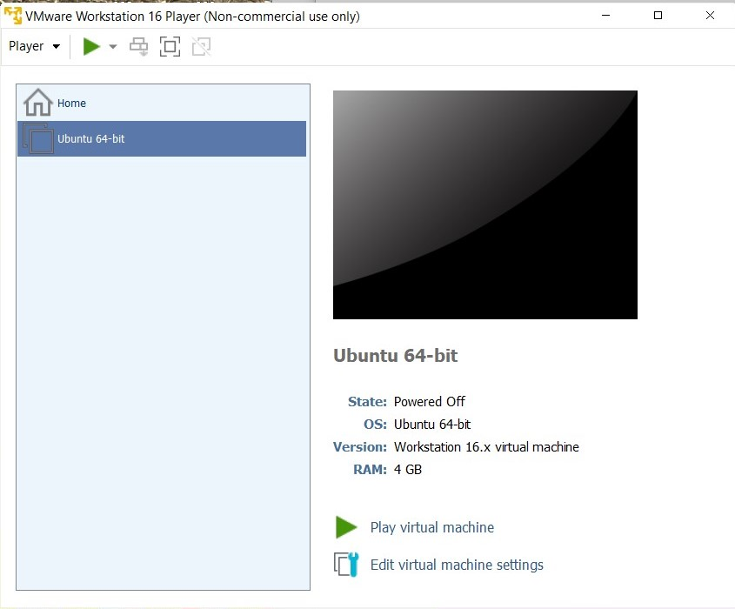

**Result:**

Hence, a virtual machine has been created successfully using VMWare Workstation And Ubuntu.